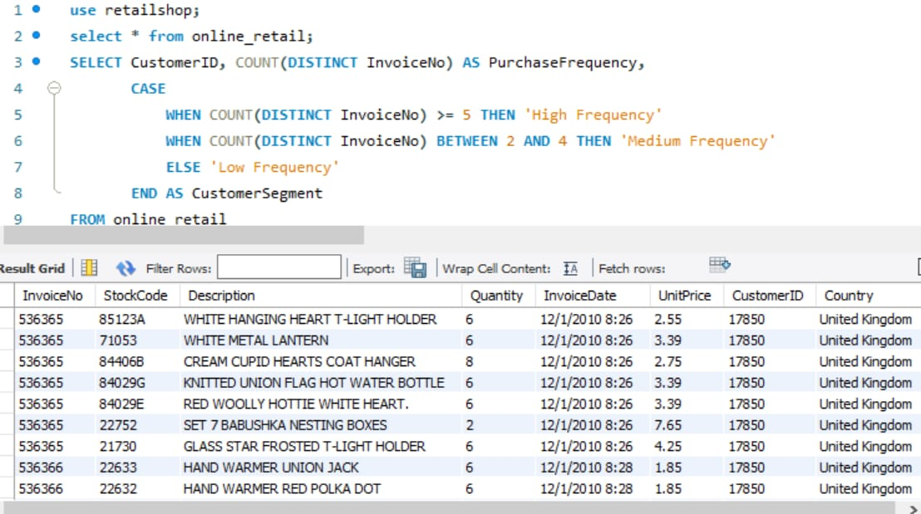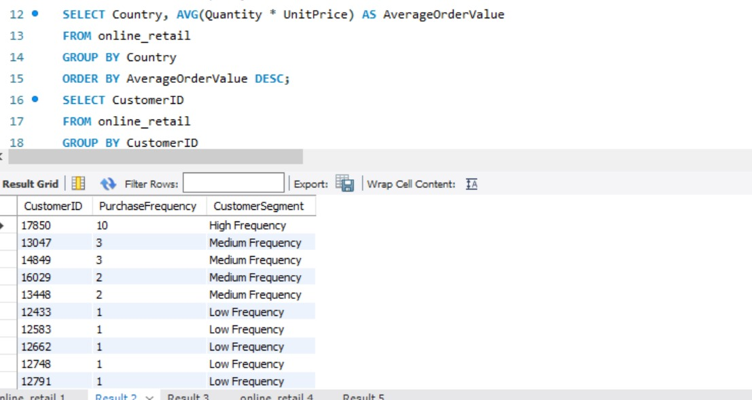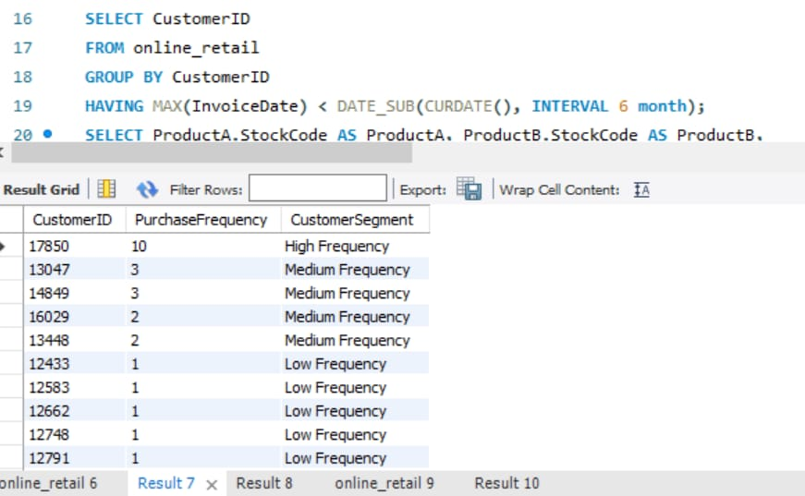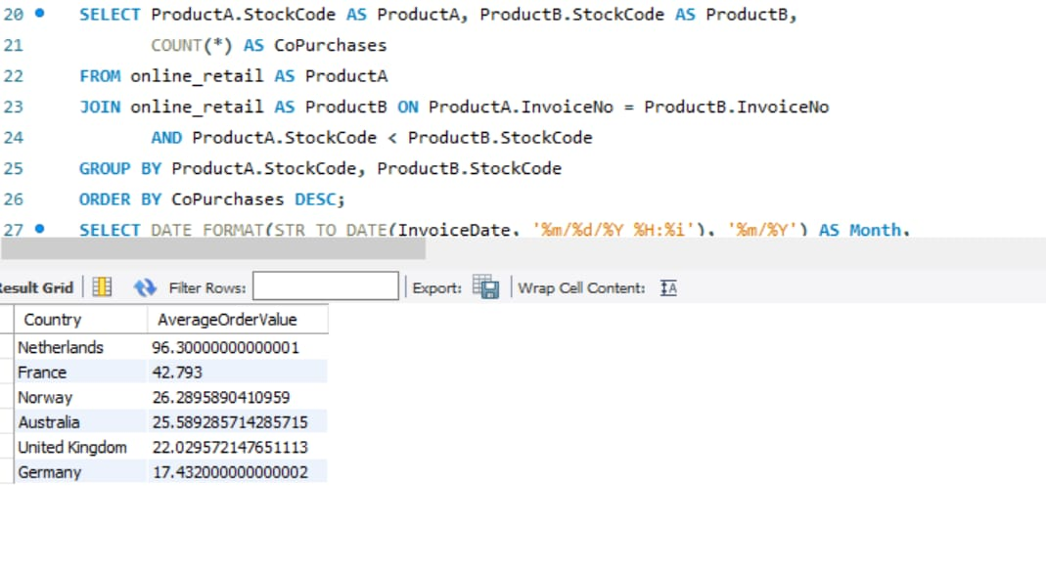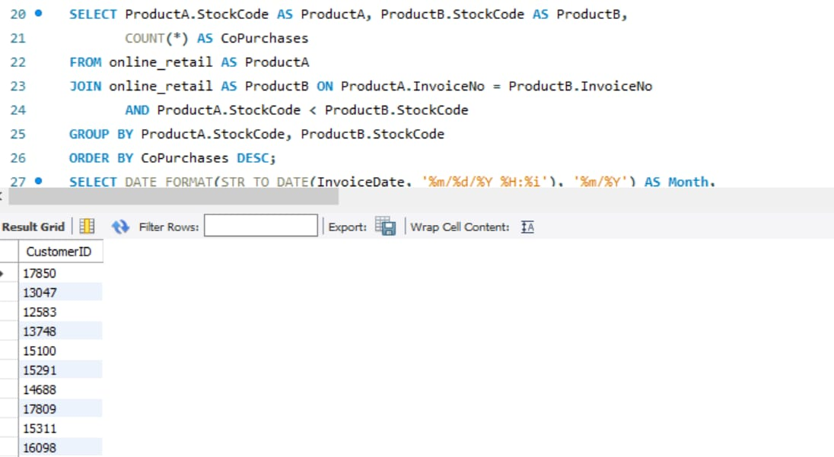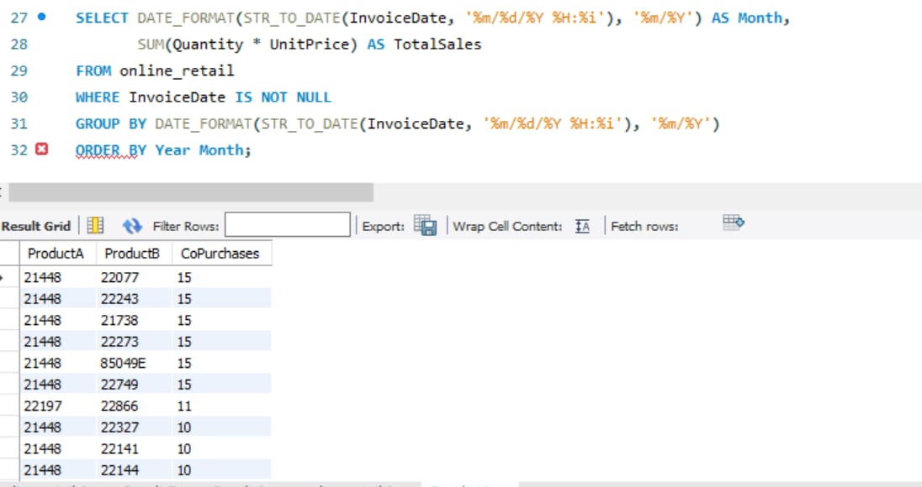

Overview:

This presentation provides a comprehensive analysis of online retail data. Key findings include customer segmentation, product co-purchases, and monthly sales trends.

Explanation:

* *Customer Segmentation:* Customers were categorized into high, medium, and low frequency groups based on their purchase history.

* *Product Co-Purchases:* Frequent product pairings were identified to understand product relationships and cross-selling opportunities.

* *Monthly Sales Analysis:* Total sales were analyzed by month to identify trends and seasonal patterns.

**Key points**

* Targeted marketing to high-frequency customers

* Cross-selling strategies to increase sales

* Inventory management based on sales patterns

* Focus on customer satisfaction to drive repeat business